 

**70th NATIONAL CONFERENCE OF TUBERCULOSISANDCHEST DISEASES**

*NATCON 2 0 1 5*

*PRECONFERENCE WORKSHOP: 19TH FEBRUARY2016*

*CONFERENCE DATE: 20th-21stFebruary 2016*

VENUE: SCIENTIFIC CONVENTION CENTRE, KING GEORGE’S MEDICAL UNIVERSITY, UP, LUCKNOW, INDIA

*(Early bird registration and abstract deadline 31ST December 2015)*

*(Regarding any information you can contact Conference Secretariat. However requests for Abstract/presentation/poster/chairperson/speaker you should contact at Secreatry General, TB Association Of India, 3 Red Cross road, New Delhi.* ***Ph No:011-23715217, fax:23711303, Email:tbassnindia@yahoo.co.in,website:www.tbassnindia.org****)*

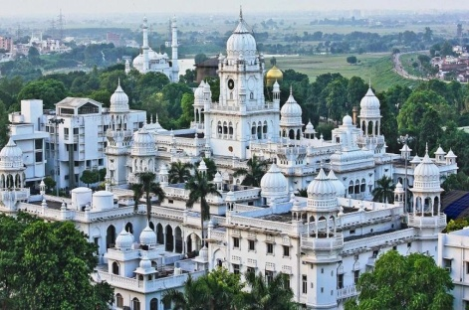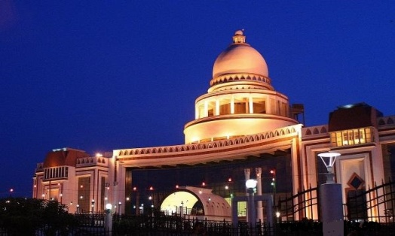

**KING GEORGE MEDICAL UNIVERSITY, UP**

**SCIENTIFIC CONVENTION CENTRE**

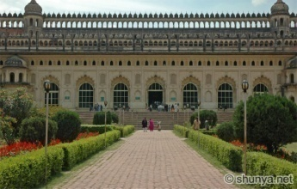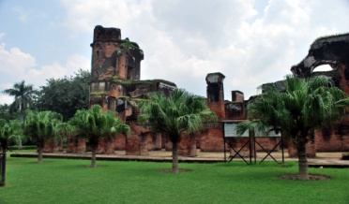

**RESIDENCY**

**IMMAMBARA**

*Organized by*

*Department of Respiratory Medicine, King George’s Medical University, Lucknow, UP and Uttar Pradesh Tuberculosis Association under the Aegis of* ***Tuberculosis Association of India***

Conference secretariat

**Dr Surya Kant**

Professor and HOD

Dept. of Respiratory medicine, KGMU, UP, Lucknow-226003 INDIA

Phone no.0522-2255167

Email:[70thnatconkgmulko@gmail.com](mailto:70thnatconkgmulko@gmail.com)

Website: www.natcon2015kgmu.com

**NATCON 2015 GREETINGS FROM LUCKNOW**

***Dear Colleagues*,**

***Department of Respiratory Medicine, King George’s Medical University and UP Tuberculosis Association under the Aegis of Tuberculosis Association of India is organizing the 70th National Conference on Tuberculosis and chest diseases.***

***NATCON-2015 will be held in Lucknow on 20th and 21st of February 2016 and will be preceded by workshops on various topics on 19th February 2016.***

***Veterans in the field will be updating on Tuberculosis and other Respiratory diseases. Lucknow is one of the oldest and historical city of India which was founded by Shri “Laxman Ji” (Younger brother of Lord Shri Rama Ji) and well known for its hospitality (Mehmannawaazi), courtesy and Nawabi culture as well asyou can enjoy the preserved Heritage(Bada and Chota Immambara, Bhulbhulaiya, Picture gallery, Residency, Shaheed Smarak and Hazratganj) and the pleasant weather. Moreover, you can enjoy the tasty food of Lucknow especially delicious Chaat, Kesariya Makhan, Rewadi, Biryani and Kabab.***

***Nearby you can visit Nemisaryana (85Km), Ram Janam Bhumi-Ayodhya (130 Km), Sangam Nagri-Allahabad (200Km), Varanasi (280Km) and Agra (350Km).***

***Looking forward for your participationfor making this event meaningful and memorable.***



Organizing secretary

**Dr Surya Kant**

Professor and HOD

Dept. of Respiratory medicine, KGMU, UP, Lucknow-226003 INDIA

Phone no.0522-2255167

Email[70thnatconkgmulko@gmail.com](mailto:70thnatconkgmulko@gmail.com)

Website: [www.natcon2015kgmu.com](http://www.natcon2015kgmu.com)

**REGISTRATION FORM**

***NATCON 2 0 1 5***

***Registration Fees***

|  |  |  |  |
| --- | --- | --- | --- |
|  | ***TILL 31STDEC 2015*** | ***TILL 31STJAN 2016*** | ***Upto 18th February 2016***  ***And***  ***Spot registration*** |
| *Delegates* | Rs 5000/- | Rs 6000/- | Rs 7000/- |
| *PG Students(certified by HOD)* | Rs 2500/- | Rs 3000/- | Rs 3500/- |
| *Workshop(for Registered Delegates)* | Rs 1500/- | Rs 2000/- | Rs 2500/- |
| *Accompanying person* | *Rs 3000/-* | *Rs 3500/-* | *Rs 4000/-* |
| *Foreign Delegates* | *USD 200* | *USD 250* | *USD 300* |
| *SAARC Delegates* | *USD 100* | *USD 150* | *USD 200* |

***Name……………………………………………………………..***

***Designation………………………………………………………***

***Institution………………………………………………………..***

***Correspondence Address………………………………………...***

***……………………………………………………………………***

***……………………………………………………………………***

***Phone ………………………………Mobile…………………………….***

***Email……………………………….***

***Mode of Payment: DD ………………. Cash ………………. Online (NEFT/RTGS)……………***

***Drawn on bank Account: 70TH NATCON 2015, Allahabad bank, KGMU Branch, Lucknow***

***Account no. 50299621876IFSC CODE: ALLA0211028***

***Organizing secretary Treasurer***

***Conference secretariat***

***Dr Surya Kant***

***Dept. of Respiratory Medicine***

***King George’s Medical University,UP, Lucknow- 226003***

***Email-*** [***70thnatconkgmulko@gmail.com***](mailto:70thnatconkgmulko@gmail.com)

***Website-***[***www.natcon2015kgmu.com***](http://www.natcon2015kgmu.com)

***Telephone-0522-2255167***

 **NATCON-2015**

70th National Conference on Tuberculosis and chest Diseases- 2015

Organized *by Department of Respiratory Medicine, King George’s Medical University, Lucknow, UP and Uttar Pradesh Tuberculosis Association under the Aegis of Tuberculosis Association of India* at *Scientific Convention Centre*

*King George’s Medical University, UP, Lucknow*

***\* Regarding request for abstract/presentation/poster/chairperson/speaker you should contact at Secreatry General, TB Association Of India, 3 Red Cross road, New Delhi.Ph No:011-23715217,fax:23711303, Email:tbassnindia@yahoo.co.in,website:www.tbassnindia.org***

**ABSTRACT FORM [Deadline- 31st December 2015]**

**(Please fill in block letter and tick appropriate box)**

I agree that this information may be used in public conference information: yes/no

If these boxes remain unchecked, it is assumed that you agree

Name_________________________________________________________

Designation_________________Age____________________place____________

Indicate desired presentation oral poster

**INSTRUCTIONS**

* Please stay within the margin
* Underline the name of the presenter.
* Abstract should be within 300 words
* use 11 to 12 point type for the text

Title (All capital) __________________________________________________________________ _________________________________________________________________________________

Authors__________________________________________________________________________

Institution ________________________________________________________________________

Text of abstract

Registered yes no attached

If yes, Registration no___________ Date___________

Signature

***Pre Conference Workshops***

***Registered conference delegates (who have also registered for workshop) can opt for any one of the following Workshops***

***1. Tuberculosis (Modern Diagnostics, RNTCP, MDR/XDR T.B.)***

***2. Non Invasive Ventilation***

***3. Sleep Study***

***4. Pulmonary Function Tests***

***Payment Details***

* ***Please send demand draft/cheque in favour of “70TH NATCON 2015” payable at Lucknow, Allahabad Bank, KGMU Branch***
* ***Payment can also be done through NEFT/RTGS/DEBIT CARD/CREDIT CARD***
* ***Delegates can register online on* www.natcon2015kgmu.com**

***Refund Policy***

* ***Cancellation on or before 15th January 2016, 25% of Registration charges will be deducted.***
* ***Cancellation between 16th – 31stJanuary 2016, 50% of Registration charges will be deducted.***
* ***No Refund/Cancellation after 31st January 2016***

***Instructions***

* ***Registration is mandatory for speakers and for delegates and students presenting papers/posters***
* ***Certificate from HOD is mandatory for student’s registration***
* ***Registration cannot be transferred***
* ***Spot registration by cash only(Not entitled for Conference Kit)***
* ***Workshop seats are limited and its registration is subjected to availability of seats.***

*Please confirm vacancy of workshop by sending in your name, designation and e mail id plus mobile/phone number to*[70thnatconkgmulko@gmail.com](mailto:70thnatconkgmulko@gmail.com)*.There are limited accommodations in campus on first come first serve basis. Please email your request.*

***Tours and Travel***

***For Air Tickets/Train Tickets/Taxi bookings/Local sight-seeing/Hotel accommodation please contact WIFI TOURS and TRAVELS (Mr. Shobit Prakash Gupta)***

***Telephone no.-0522-2649997, Mobile-09696444441, email- spgupta353@gmail.com***

**ORGANISING COMMITTEE**

**PATRON**

**PROF. RAVI KANT**

**Vice Chancellor, King George’s Medical University, U.P., Lucknow**

|  |  |
| --- | --- |
| **ORGANISING CHAIRMAN:**  **ORGANISING SECRETARY:**  **CO-ORGANISING SECRETARY:**  **TREASURER:**  **JOINT ORGANISING SECRETARIES:**  **EDITOR AND SCIENTIFIC SECRETARY (LOCAL):** | SHRI R.C.TRIPATHI (Retd. IAS)  Dr. SURYA KANT  Dr. K.N.PATNI  DR.AJAY KUMAR VERMA  Dr. VED PRAKASH  Dr. DARSHAN KUMAR BAJAJ  Dr. ANAND SRIVASTAVA |